Linux Directory Structure
Linux: Linux is an open-source operating system (OS) based on Unix. It manages hardware resources (CPU, memory, storage, devices) and provides an environment for users and applications to run.
🔹 Core (Kernel): The heart of Linux that directly interacts with hardware (CPU, RAM, disks, network, etc.).
🔹 Shell: The command-line interface where you type commands to interact with the system.
🔹 File System: Organizes data in directories and files.
🔹 Utilities & Applications: Tools (like ls, cp, grep) and programs (like browsers, editors, servers).
Linux Directory Structure:
In Linux, everything is treated as a file even if it is a normal file, a directory, or even a device such as a printer or keyboard. All the directories and files are stored under one root directory which is represented by a forward slash /.
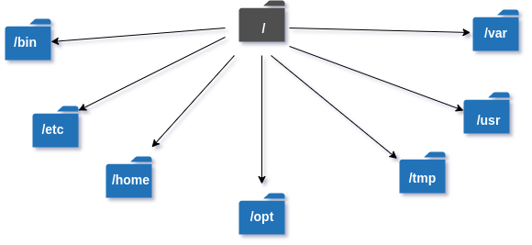
/ (Root):
This is the top-most directory in Linux — the starting point of the entire filesystem. Every other file and directory branches out from here. Without /, the OS cannot function.

/bin:
/bin contains essential user-level Linux commands like ls, cp, and cat that are needed during normal operation.
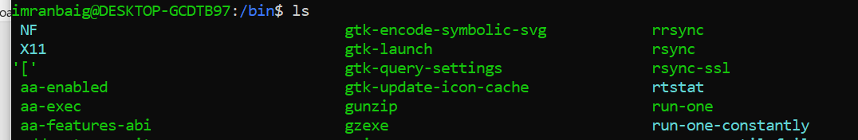
/sbin:
/sbin stores system administration commands used by the root user for managing or repairing the system, especially during boot.
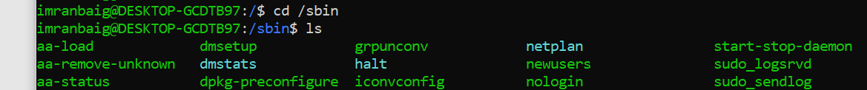
/etc
This directory holds all major system configuration files. Anything that controls system behavior like networking, users, and services — is typically found here. Changing files in /etc directly affects how the OS functions.
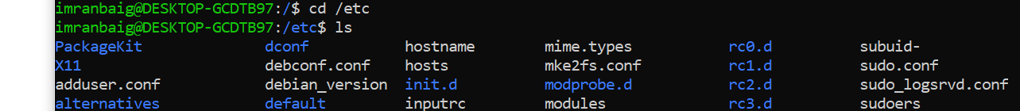
/home
/home contains individual user folders where personal files, downloads, and settings are stored.
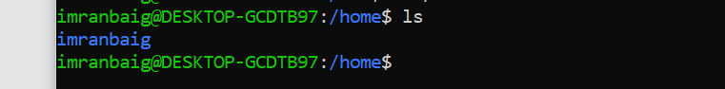
/var
This directory stores data that continuously grows and changes such as logs, caches, and spool files. It plays a crucial role for services and applications that generate runtime information. A full /var can cause system problems, especially in servers.
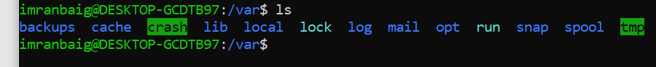
/usr
Most installed applications, commands, and libraries are located here. It includes subdirectories like /usr/bin and /usr/lib that support user applications. It is often the largest portion of the system.
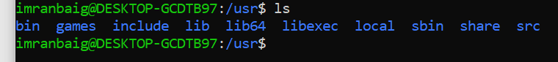

/proc
These are virtual filesystems that don’t store data permanently. /proc provides details about running processes and system resources.

/sys
It exposes information about hardware devices and kernel interactions. Reading these files gives a live view of the operating system.
/dev
This directory contains special device files that represent hardware components like storage drives, terminals, and USB devices. It allows Linux to treat hardware as files, making interaction simple and consistent. Tools can access devices just by reading or writing to these file nodes.
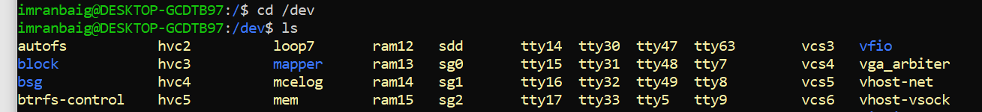
/opt
This directory is used for installing optional or third-party software applications. Programs installed here are usually self-contained and kept separate from system files. It is commonly used for commercial software or manually installed packages outside the default package manager.
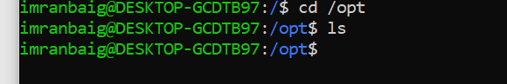

/tmp
Holds temporary files created by applications and system processes. Data here is not permanent and is usually cleared during reboot. It provides space for programs to store short-term working files.
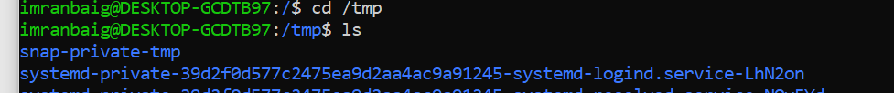
/mnt
A generic mount point used by system administrators to manually mount external storage like additional drives or network shares. It provides a temporary access location when attaching filesystems.
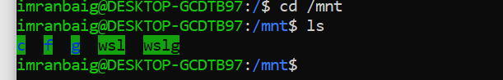
/media
Used for automatically mounted removable devices such as USB drives, CDs, and DVDs. When you plug in external storage, it appears here for easy access.
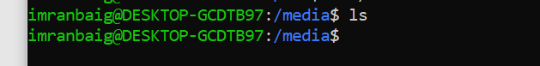
/boot
Contains the files required for the boot process, including the Linux kernel, initrd images, and bootloader configuration (like GRUB). If anything in /boot is damaged or deleted, the system may fail to start.
